**Manual Project Build with Tomcat 10**

1. **Launch an EC2 Instance**

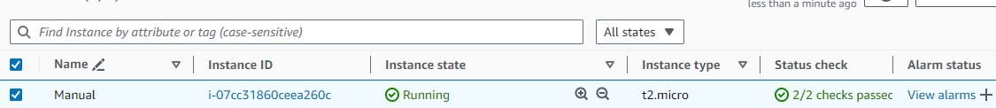

1. **Now login and run the below commands to update and upgrade the packages of the OS.**

apt update -y && apt upgrade -y

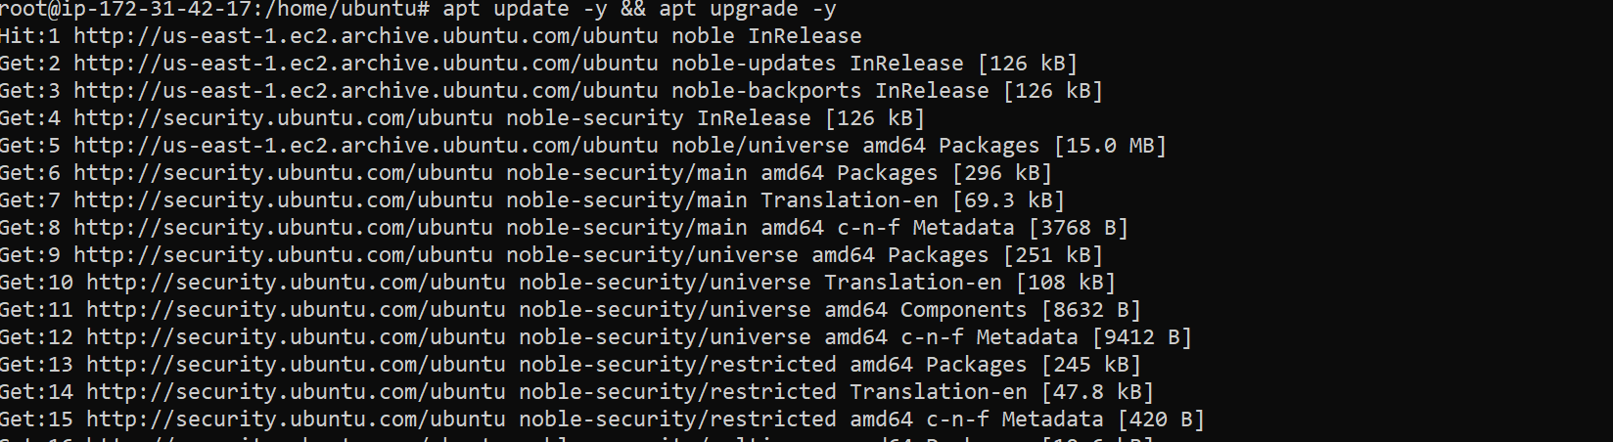

1. **Now install git and git version using the below command.**

apt install git -y

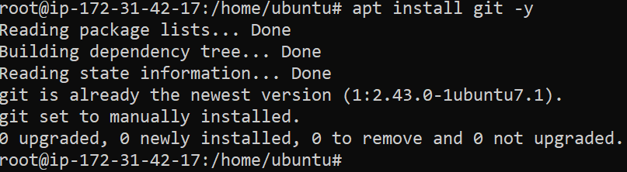

git –version



1. **Now clone the git repository which you want to build the project and check if the repo is cloned properly.**

git clone "https://github.com/shashirajraja/Train-Ticket-Reservation-System.git"

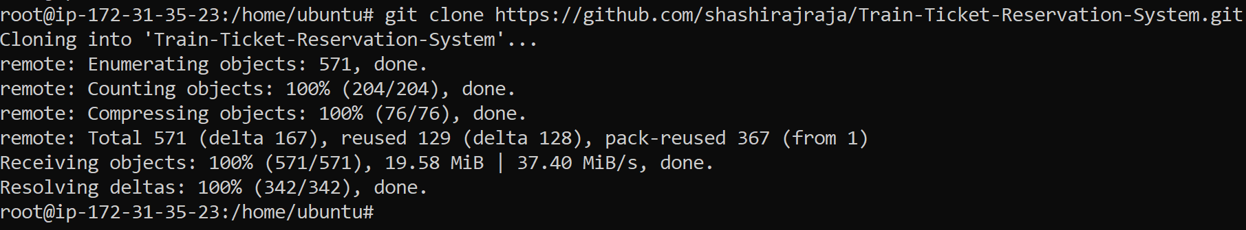

ls -ltr

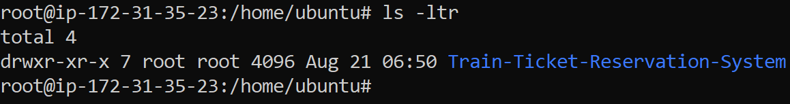

1. **Go inside the cloned project directory and verify the source code and pom.xml file is present so that we can build the project.**

cd Train-Ticket-Reservation-System/

ls -ltr

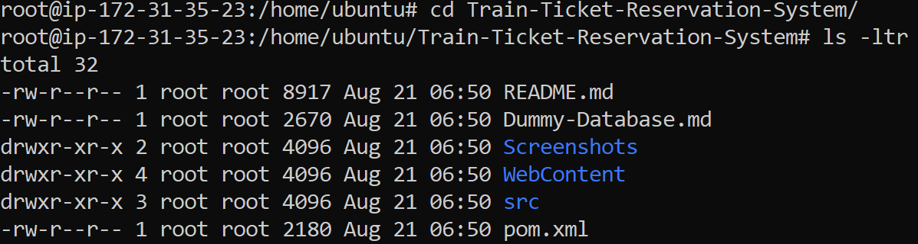

1. **To Build the project, we need to install Apache Maven Tool and verify version which helps in testing the source code and builds it as a war or jar file in case of java.**

apt install maven -y

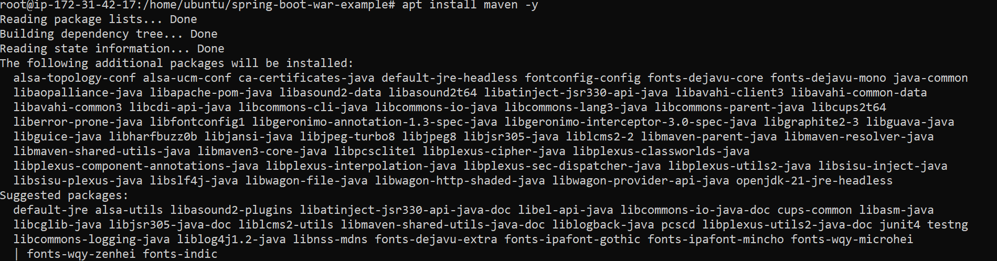

mvn –version

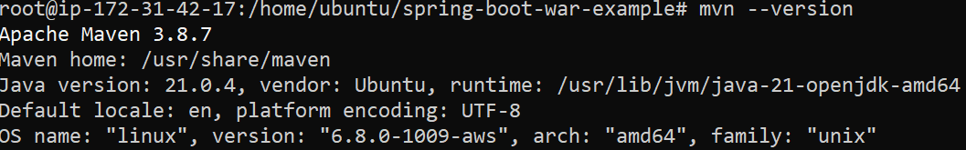

1. **Now we will test the code using below Maven command which uses information from pom.xml.**

**NOTE: We need to run the below command from the same location where pom.xml is located**

mvn test [Below output comes if the source code is without any errors]

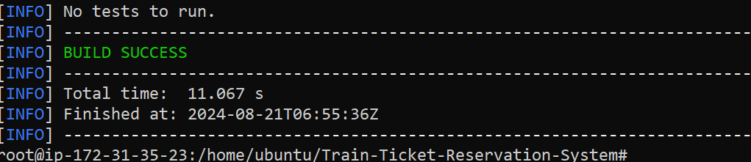

1. **Now once we get the above output, we run the below command to build the project.**

mvn install [Below output shows project build is successful and war file is created]

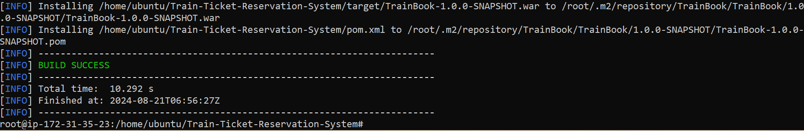

1. **Once the build is successful, a folder named “target” is created which has the war file in it.**

ls -ltr

cd target/

war file created by the name TrainBook-1.0.0-SNAPSHOT.war

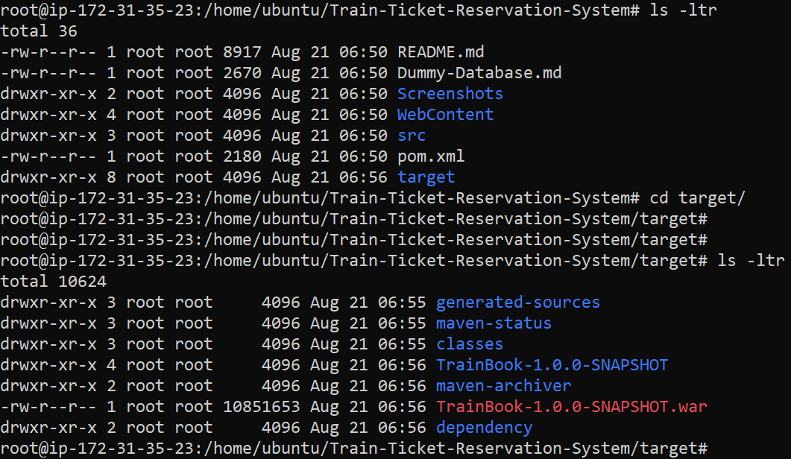

1. **Now we can rename the war file to example hello.war and move it to an artifact (in our case the artifact is /tmp)**

mv TrainBook-1.0.0-SNAPSHOT.war Train.war (rename war file)



mv Train.war /tmp (war file moved to artifact location)

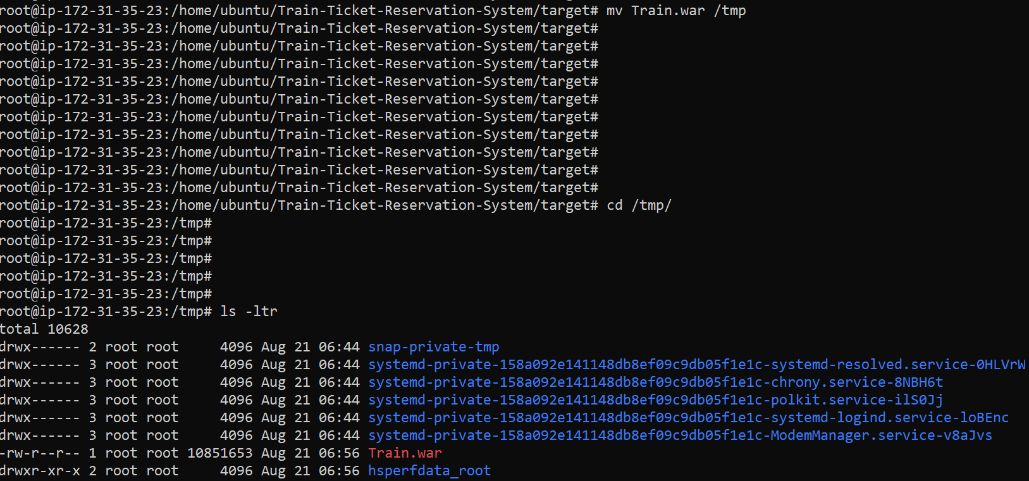

1. **Now we install Apache tomcat version 10 so that we can check code is working in WEBGUI.**

Pre-requisite for installing Tomcat is to install open-jdk and check java version

apt install openjdk-17-jdk -y

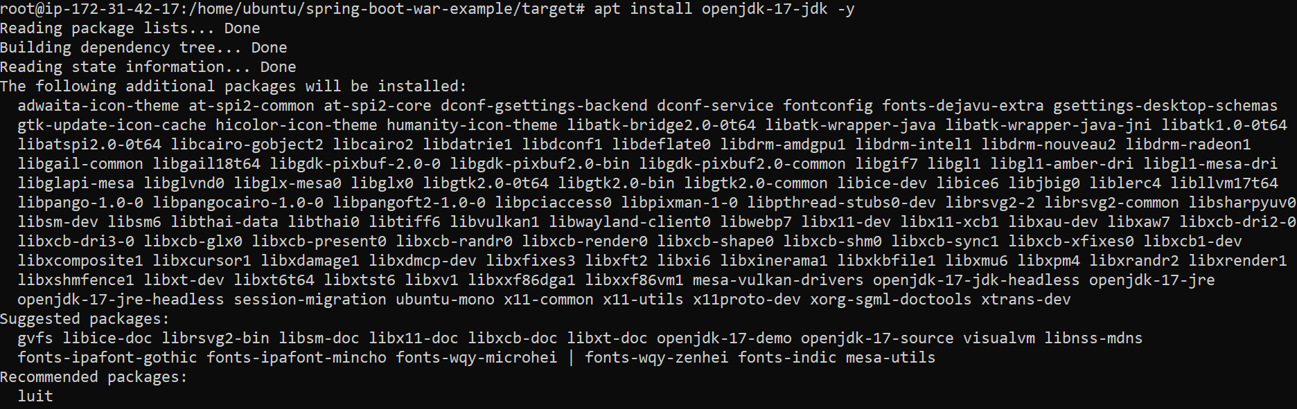

java –version

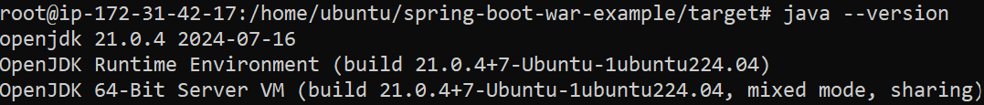

1. **Now install Tomcat10. Below are the steps to install tomcat 10.**

Apt install tomcat10 -y

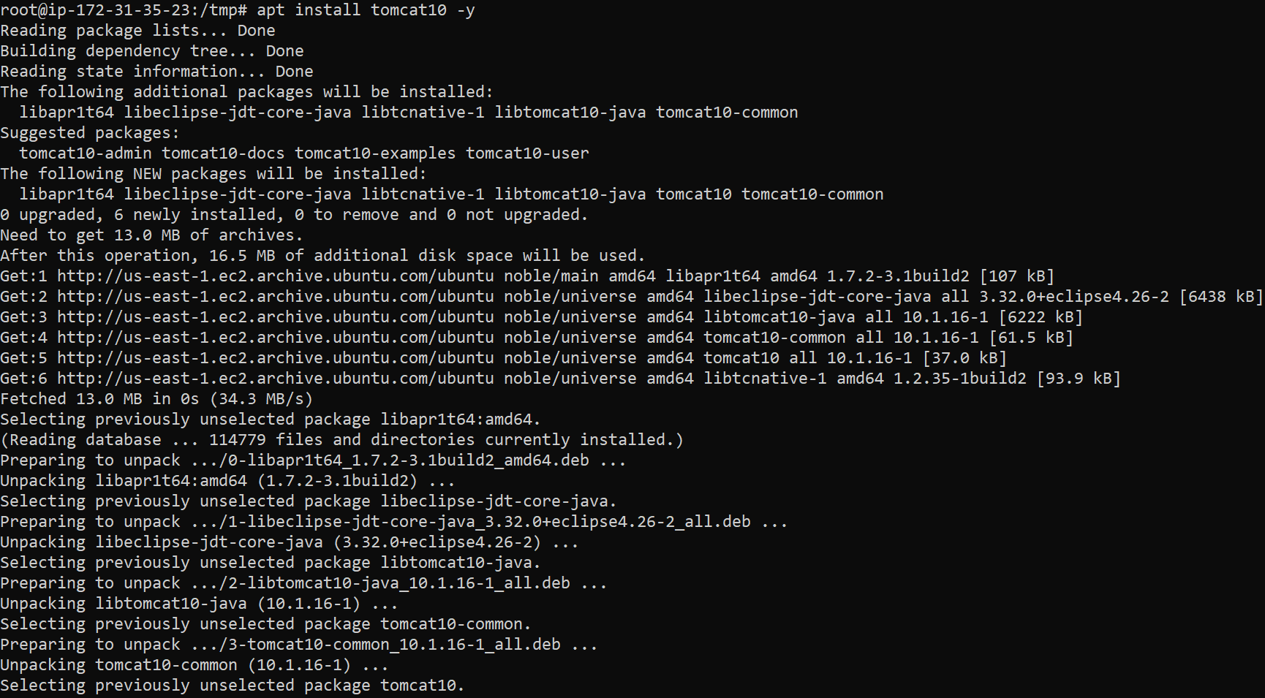

1. **Since Tomcat10 is installed with Ubuntu, the tomcat service is now installed on below location**

/usr/lib/systemd/system/tomcat10.service

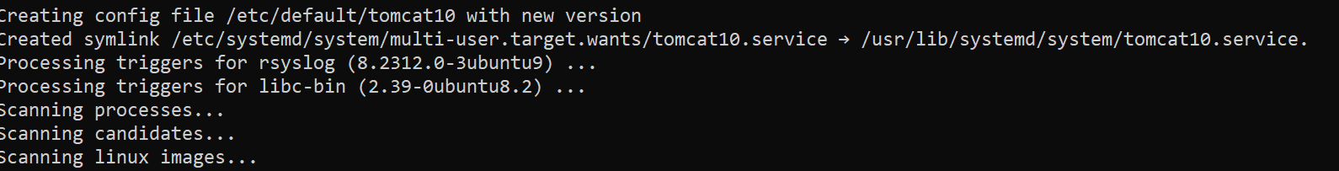

1. **We will verify that the tomcat10 service is running.**

systemctl status tomcat10

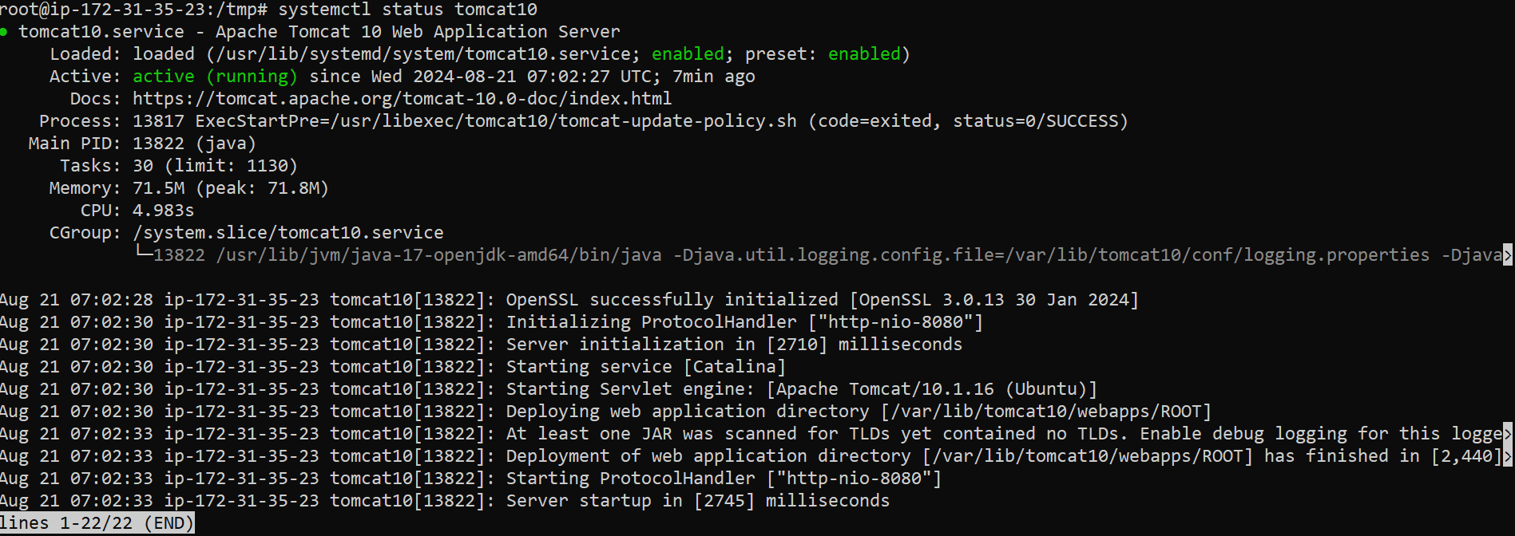

1. **We will verify that tomcat is running or not on the WEG UI by accessing tomcat URL – PublicIP of EC2 instance:8080 (Tomcat works on port 8080)**

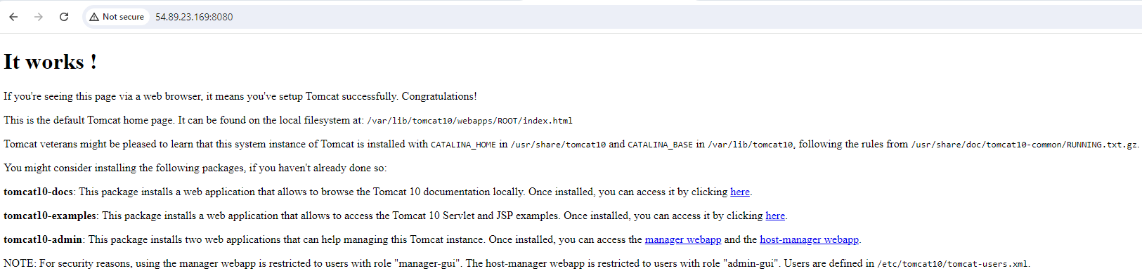

1. **Now we will copy the Train.war file from /tmp to /var/lib/tomcat10/webapps (Location of Tomcat10). Once the war file is copied in webapps folder we see that Train folder is also created in it.**

cp Train.war /var/lib/tomcat10/webapps/

ls -ltr

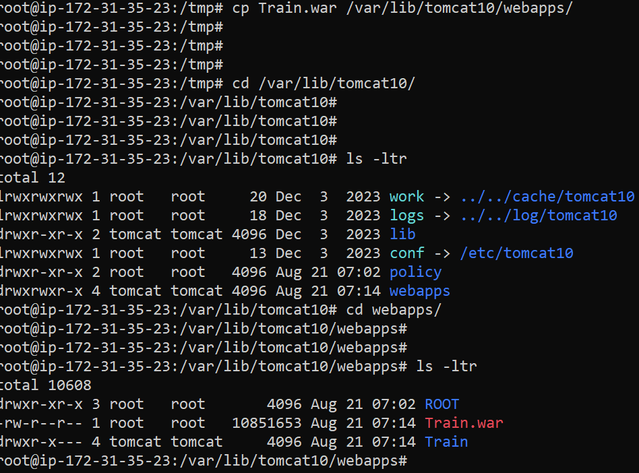

1. **Now we will verify that code is accessible on tomcat GUI by accessing tomcat** [**URL:8080/**](URL:8080/)**Train**

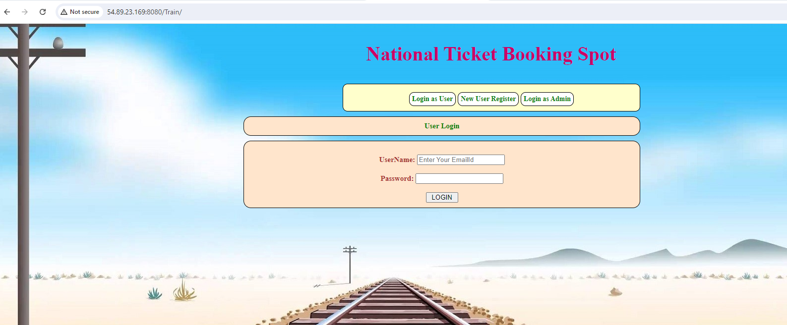

1. **Once we get the above output, we are sure that our manual build is successful visible and tested.**